Rachel Fischmar

Daniel Cruz

Ryan Holthouse

Nathan Mysona

Wyatt Combs

CSE 201C Group 7 Final Project Submission

## Source Code:

A zip file has been submitted on Canvas along with this report.

## Requirements:

* The user can see workouts
* The user can adjust to different size screens
* The user can separate workouts by muscle group
* The user can hover over tiles to change the text
* The user can create an account
* The user can log in to the system
* The user can sign out of the system
* The user can change their username
* The user can change their password
* The user can change between light and dark mode
* The user can search for workouts
* The user can leave reviews on the website
* The user can leave comments on other people’s reviews
* The admin can approve reviews and comments
* The user can “favorite” workouts

## Working Application:

<https://ceclnx01.cec.miamioh.edu/~cruzdg/intro-to-software-engineering-project/html/AllWorkouts.php>

## Use Case Diagram:



## Class Diagrams:

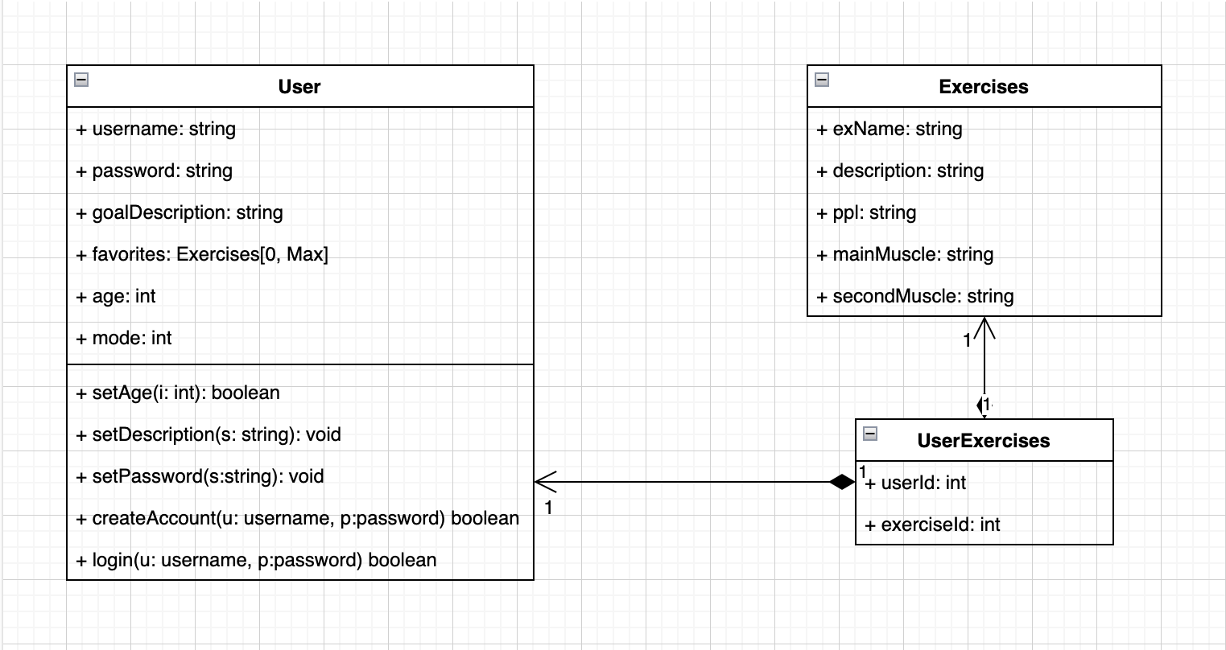

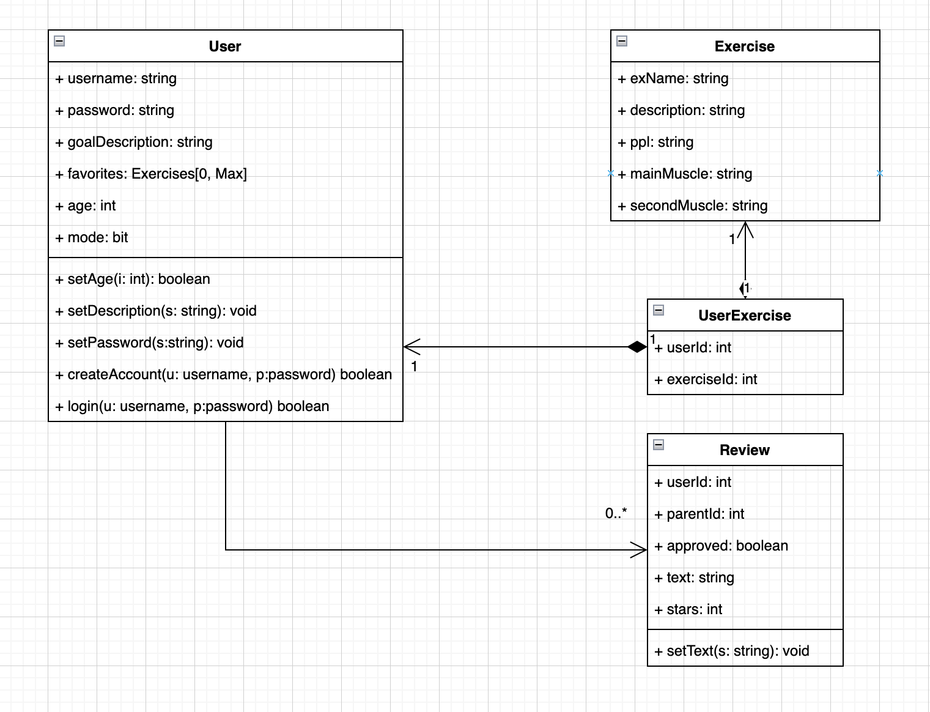

## Sequence Diagrams:

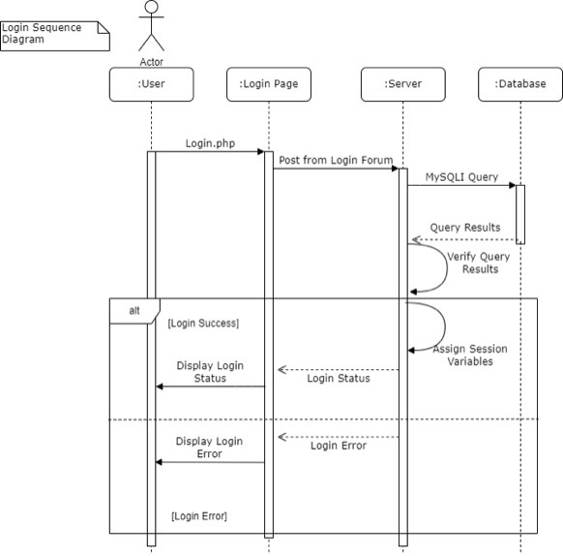

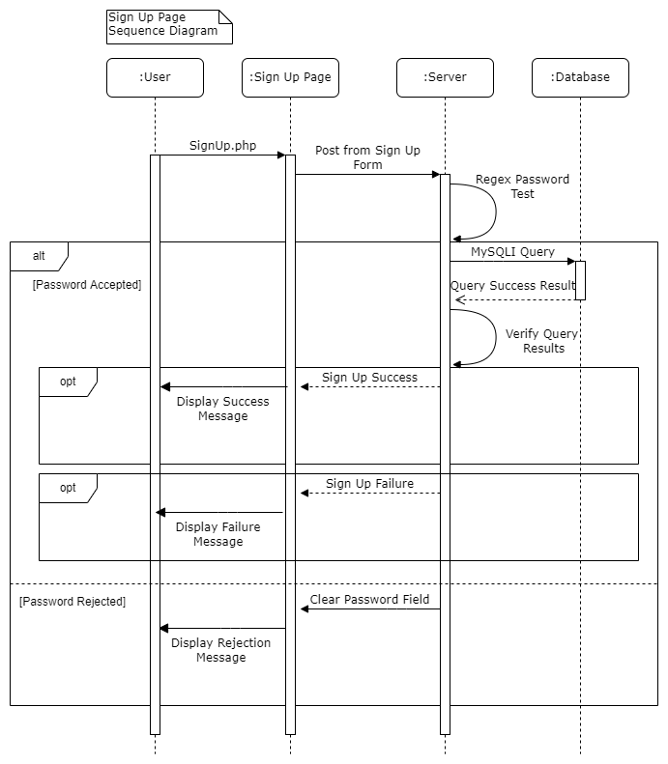

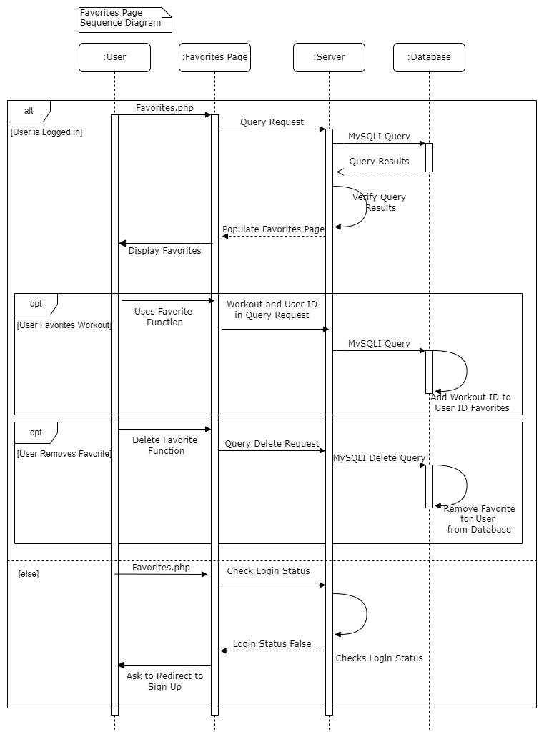

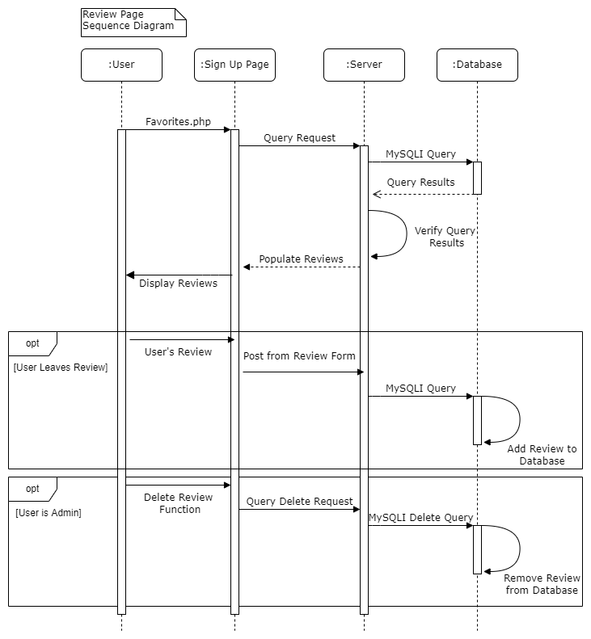

## State Diagrams:

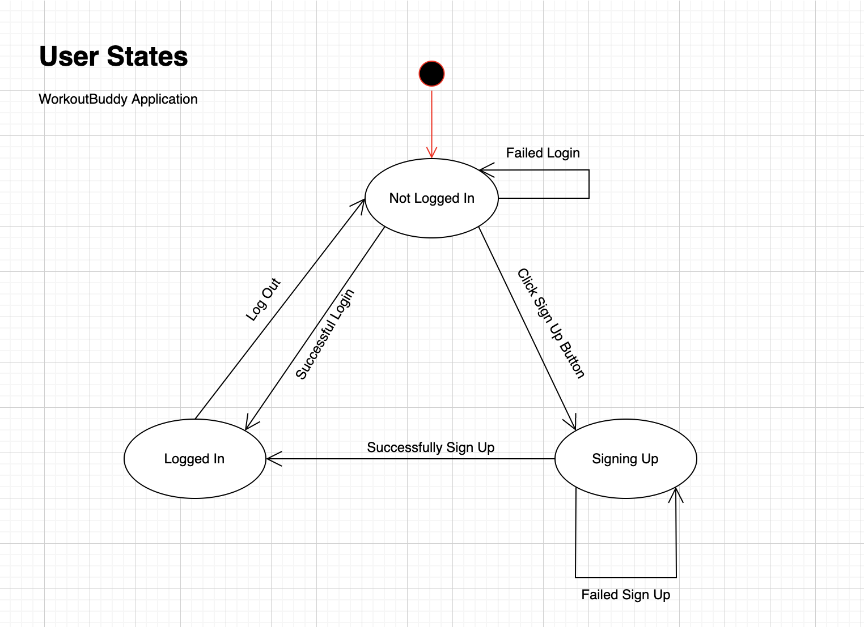

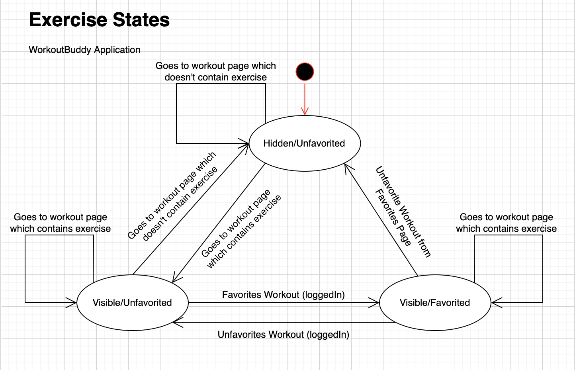

[**Website Navigation State Diagrams**](https://docs.google.com/document/d/1HL0h-RqVtRVfcQZJXtsGg1K8AFcJNyClk7P7UYEfgdE/edit?usp=sharing)

## Workout Buddy User Manual:

1. Click on the website URL below or type it into your browser: <https://ceclnx01.cec.miamioh.edu/~cruzdg/intro-to-software-engineering-project/html/JimBuddies.php>
2. Click on the “Sign Up” button (top right of the screen)
   1. Enter a new username
      1. Can only be letters and numbers
      2. Must have at least 4 characters
   2. Enter a new password
      1. Can have any of these characters: a-zA-Z0-9!@#$%^&*();:.,/
      2. Must have at least 8 characters
   3. Enter workout goals
   4. Enter your age
3. Click on the “Log In” button (top right of the screen)
   1. Enter the username and password you created
4. Click on the “Home Page” tab to learn about Workout Buddy
5. Click on the “All Workouts” tab to see all of the workouts on Workout Buddy
   1. Type a workout into the search bar in order to search for a specific workout
   2. Underneath each workout, the primary (main) and secondary muscles being used in the workout are listed
   3. Roll over the square with the workout for a spinning animation to occur
6. Click on the “Chest Workouts” tab to see chest workouts
7. Click on the “Push Workouts” tab to see push workouts
8. Click on the “Pull Workouts” tab to see pull workouts
9. Click on the “Leg Workouts” tab to see leg workouts
10. Click the “Add to Favorites” button at the bottom of a workout to add it to your favorites
    1. Click on the “Favorited Workouts” tab to see your favorite workouts
    2. Must be logged in in order to favorite workouts
11. Click the “Reviews” button tab to read reviews about Workout Buddy
    1. Scroll to the bottom and type in the “Leave a Review” text box to leave a review about Workout Buddy
       1. Press the “Comment” button to publish your review
    2. Type in the “Reply” text box to comment on other people’s reviews
12. Press the “Toggle Light/Dark Mode” button to switch between light and dark mode for the page you are currently on
13. Press the “Account Settings” button to change your account settings
    1. If you’d like to change your username, enter a new one in the text box where it says “Change Username:”
    2. If you’d like to change your password, enter a new one in the text box where it says “Change Password:”
    3. Use the dropdown to permanently set whether you’d like to keep your account in light or dark mode
    4. Press “Update Settings” to save these changes
14. Press the “Log Out” button to log out of your account

## Technical Documentation:

* Inline comments are available for viewing for each file in the zip file

## Citations:

JQuery: cited in code

## Installation/Compilation Instructions:

* Type the link into the browser or click on the link below to access the web application
* <https://ceclnx01.cec.miamioh.edu/~cruzdg/intro-to-software-engineering-project/html/JimBuddies.php>

## Team Technical Skills and Goals:

**Rachel Fischmar:** As Project Manager, my organizational skills were imperative for this project. At the beginning of iteration 1, I made a Google Drive folder with different subfolders within the main one in order to keep all of our documents organized. The major subfolders were for deliverables, agendas, and code information/documentation. I created all of our agendas and deliverables documents each week that we presented to our TA during deliverables meetings. I also organized our group’s virtual meetings using Google Calendar so we were able to meet on Google Meets. Throughout the three iterations, we usually met Sunday night and Tuesday night on Google Meets in order to touch base on the project and practice for our deliverables meetings that were held on Wednesday evenings. In addition to this, I was also responsible for being the main point of contact for our TA, Isaiah. If a group member had to miss a deliverables meeting or the group had a question about the project that we didn’t ask during the deliverables meetings, I always made sure to email him. Also, I always made sure that our agendas and deliverables were shared with Isaiah prior to our deliverables meetings so that he was able to access them on his own device. Another task I took on as Project Manager was delegating tasks to the rest of the group members. We decided to use GitLab for our task board, and I was in charge of assigning tasks to our programmers, Ryan (front end) and Nathan (back end). Also, if diagrams needed to be made for deliverables or a certain requirement needed to be completed by a certain date, I was in charge of delegating those tasks to my group mates. Finally, I created the slideshows for our three public demonstrations, which were important to show our group’s progress to our professor. I made sure that all of the necessary components of the demonstration were included in our presentation so that we were able to make a great impression on the CEO (Professor Mattox).

**Daniel Cruz:** As technical manager, my main responsibility was really putting out any issues that came up, and working to ensure that they never happened again. A lot of issues related to git merging was the start, but working to produce a step by step document that would allow the developers to use git easily and create less issues later on. I was also responsible for setting up the entire base of how the website would begin to look and function. I set up a basically rough draft for the entire outline before adding content later on. Moreover, I also worked on the more difficult requirements in order to ensure that they got done in a timely manner. I essentially started the basics of creating a server side environment that would allow our website to go from being a static web page to a dynamic web application. All in all, any sort of technical issues that came up during the project, I worked to fix as quickly as possible.

**Wyatt Combs:** As the data layer programmer, I started out by designing the database that I believed we needed. This was roughly based off of the properties in our class diagram starting with Users, Exercises, and UserExercises (favorited workouts). I created the database and populated it with some mock data to test out queries. After this, I learned some php to connect the database with mysqli which was hosted on my localhost. I spent some time figuring out how to host the database which I used AWS for. After the database was hosted on the cloud and connected to the website, I made queries to populate the workout pages with different exercises, using php to generate html with the specific database results. To make our website more friendly, I also created a search bar which had a procedure instead of a query that I created in the database to reduce clutter in the php pages. One of the most complicated tasks I worked on was creating a reviews page with allowed comments. I used forms to post review properties, created a Reviews tables with each record referencing a parent it is replying to (null for comment), created a procedure to make sure the user is logged in and no duplicate comments, and used php to generate comments in html. With this, I made all comments come in as unapproved and set up another page for admins to approve comments before they could be shown online. My last large task was adding favorite buttons to every workout card which would use a similar submit form like comments, checking the same parameters and populating the favorite workouts page. Along with these coding tasks, I also created the class diagrams and some of the state diagrams.

**Ryan Holthouse:** As front end programmer, my main goal was to help design and develop the user experience with the website. Both at the start of and throughout iteration 1, this goal was manifested and developed through work on the outer appearance of the website. With the few tabs we had at the time, most of the work was making sure that items which were populated looked clean and satisfying for users, as well as making sure we had the tabs and button functionality that we needed. These responsibilities were handled largely in HTML and CSS given their prevalence in the field, as well as some short JQuery work for some of the built-in functionality. After we moved out of iteration 1 and into iteration 2, we were focused largely on refining what we had, as well as adding some functionality and connectivity with the database. As such, my role was largely centered around cleaning up some of the outward facing content that encompassed the newly added functionality. Some particular instances of this include redesigning the login and sign up pages with newly styled frames for the pages, which were built into our existing CSS files and added on, as well as stylizing the dark vs. light mode style sheets to allow for a different look for users. After the twilight of iteration 2, my work has involved a lot more documentation than in previous iterations. I worked largely on improving and refining the use case and website navigation diagrams. Particularly, I’ve brought them up to speed with the rest of our project so that they include everything that we’ve added, as well as updated them stylistically to better match the UML appearance we know and love. I went through our files and added several comments, both citing the libraries we used in each file as well as adding some inline comments that explain generally what is happening in a given section for ease of use and understanding. Back on the coding and design side of things, I helped to add in the links and navigation to our new review page and account settings pages. In this iteration we also added functionality for favoriting workouts, and once the buttons and functionality were in, I worked to center and bottom align all of these elements through some tricky CSS so that everything was consistent despite the varying lengths of text and titles for each workout. On top of this, I also dipped into the php side of things and set these elements up so that if a user is not logged in, the favoriting workouts button doesn’t appear at all, rather than just sitting as a non-functional button as it was before.

**Nathan Mysona:** Working as a back end developer on this project, my job was to make sure that the website's functionality was working and that everything was connected properly. At the beginning of this project I had to work with Dan to decide which language we were going to use for the server/back end development of the website. It was decided that we were going to use PHP as our primary language for server side functionality, this was due to the fact that PHP easily interfaces with HTML, which a large portion of the front end was already done with, and because it allowed us to communicate with the database. I was unfamiliar with PHP or web server programming before this project, so my first goal was to familiarize myself with these concepts and languages to complete my other tasks. The first major hurdle that needed to be tackled was that, after the user was logged in, how was that status going to be saved from address to address. We talked about possibly using an address variable, which would have been very insecure, so after some research I found that PHP had a built in system for dealing with this problem, session variables. We used session variables for a multitude of variables that needed to be saved from address to address while the user interacted with the website. When we had a better idea of the different functions we needed to implement, I was tasked with creating sequence diagrams for the major functions. I decided that the main sequence diagrams that needed to be focused on were: logging in, signing up, leaving reviews, and favoriting workouts. These were the most complicated functions of the website that I felt needed more detail. I tried to give a relatively detailed view of how the logic of the different functions could work. Once it was time, I worked with Dan and Wyatt to complete the website's backend functionality.

## Bonus Objectives we Completed:

**Database:** We were able to connect a database to our project to store workouts, usernames, passwords, account settings, etc. We did this by having a PHP backend for our web server and running mySQLi queries. The database is also being hosted through AWS and is publicly accessible.

**Usability:** Our website is very user friendly and intuitive. Users can create accounts, log in, toggle between light and dark mode based on preference, search for workouts using a search bar, find workouts by category using the top bar, favorite workouts, leave reviews, and suggest workouts to be added. It is very easy for users to access all of these features, and our customer (TA Isaiah) found these features to be very intuitive as well.

**Web Application:** Our project is in the form of a web application. We originally started with HTML files just to operate as a web application, but later on, these were changed over to PHP files in order to store login information and communicate with the database. Additionally, we employ a couple of different CSS files, mainly to differentiate between the light and dark mode settings available to the user, but generally they help to set up the style of our website as a whole. These files are hosted on a Linux server so they are publicly accessible.

**Customer Satisfaction/Functionality:** According to our customer (TA Isaiah), he was very satisfied with our web application, as well as our deliverables each week. He was often impressed with how quickly we were able to complete requirements and diagrams throughout each iteration. He really liked all of the ideas we brought to the table, as well as how we executed said ideas, and we’re very glad that we achieved customer satisfaction as a result of our hard work as a group. Our web application functions properly, and users should have an easy time navigating the site.

## 